SMART TASK SCHEDULER WITH DYNAMIC PRIORITY MANAGEMENT

1. Title Page
Course Name: Object-Oriented Programming
Project Title: Smart Task Scheduler with Dynamic Priority Management
Student Name: Samriddhi Sengupta
Roll Number: 12024052004020 (IT -21)
Instructor Name: Dr. Soumadip Biswas , Dr. Susovan Jana ,Dr. Swagatam Basu
Semester: Spring 2026

2. Problem Statement
In today’s fast-paced academic and professional environments, individuals are required to manage multiple tasks simultaneously. These tasks often differ in terms of urgency, importance, and deadlines. Traditional task management tools typically rely on static prioritization, where users manually assign priority levels. However, such systems fail to adapt dynamically when task conditions change, such as approaching deadlines or shifting priorities.
This limitation leads to inefficient scheduling, missed deadlines, and decreased productivity. Furthermore, users often lack real-time feedback about task updates, making it difficult to track progress effectively.
To address these issues, this project proposes a Smart Task Scheduler that dynamically manages tasks using Object-Oriented Programming principles. The system supports multiple scheduling strategies, such as fixed priority and deadline-based prioritization, allowing tasks to be reordered dynamically.
Additionally, the system implements an observer mechanism to notify users about changes such as task addition, updates, or completion. The use of modular architecture ensures scalability, maintainability, and extensibility.
The primary objective is to design a system that not only demonstrates strong OOP concepts but also provides a practical and efficient solution for task management.

3. System Design
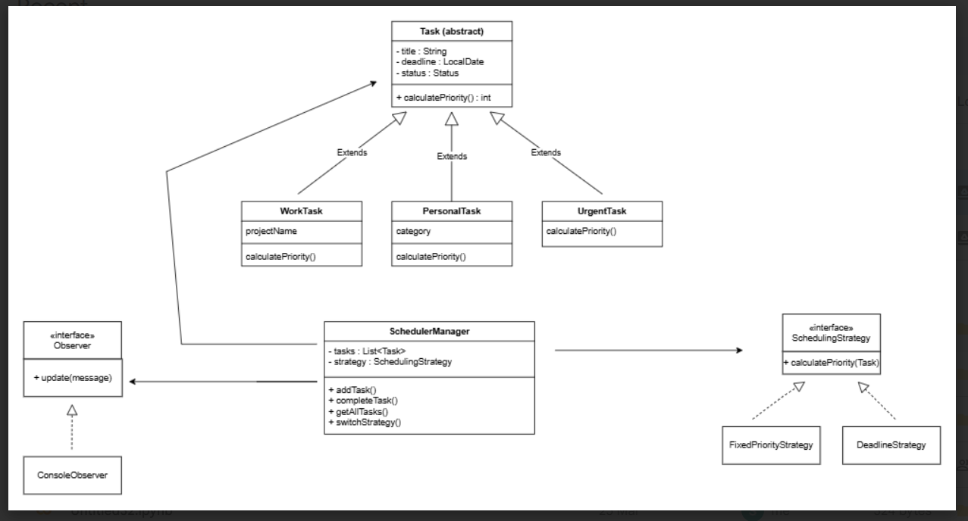

3.2 Description of Major Classes
Task (Abstract Class)
The Task class serves as the base abstraction for all types of tasks. It encapsulates common attributes such as title, deadline, and status. It also defines an abstract method calculatePriority() which must be implemented by all subclasses.
This design ensures that all task types follow a consistent structure while allowing flexibility in priority calculation.
WorkTask
Represents tasks related to professional or academic work. It includes an additional attribute such as projectName. The priority is typically moderate to high, reflecting its importance.
PersonalTask
Represents personal activities such as shopping, exercise, or hobbies. These tasks may optionally include deadlines and are assigned relatively lower priority compared to work or urgent tasks.

UrgentTask
Represents high-priority tasks that require immediate attention. These tasks override the priority calculation to always return the highest value.
SchedulingStrategy (Interface)
Defines a contract for priority calculation. This abstraction allows the system to switch between different scheduling algorithms dynamically.
FixedPriorityStrategy
Uses the inherent priority defined within each task. This strategy is simple and relies on predefined values.
DeadlineStrategy
Calculates task priority based on the proximity of the deadline. Tasks with closer deadlines are assigned higher priority, enabling dynamic scheduling.
SchedulerManager
Acts as the core controller of the system. It maintains a collection of tasks and applies the selected scheduling strategy. It also manages observers and notifies them when task-related events occur.
Observer & ConsoleObserver
Implements the Observer design pattern. The Observer interface defines an update method, while ConsoleObserver provides a concrete implementation that prints notifications to the console.

3.3 Package Structure
The project follows a modular package structure:
- model → Contains all task-related classes
- strategy → Contains scheduling strategies
- manager → Contains the core scheduler logic
- observer → Handles notification mechanisms
- persistence → Responsible for saving/loading tasks
- main → Entry point of the application
This separation ensures low coupling and high cohesion.

3.4 Interaction Flow
- The user inputs task details through the console interface.
- A specific task object (WorkTask, PersonalTask, or UrgentTask) is created.
- The task is added to the SchedulerManager.
- The active scheduling strategy calculates its priority.
- Observers are notified about the new task.
- Tasks can be viewed, updated, or marked as completed.
- Completed tasks trigger observer notifications.
- Tasks may be saved or loaded using persistence mechanisms.

4. OOP Concepts Demonstrated
4.1 Abstraction
Where Used: Task class
public abstract class Task {
protected String title;
protected LocalDate deadline;
public abstract int calculatePriority();
}
Why Used:
Abstraction hides implementation details and provides a common structure for all task types.
Explanation:
The abstract method ensures that each subclass defines its own priority logic, enforcing consistency and flexibility.
4.2 Inheritance
Where Used: WorkTask, PersonalTask, UrgentTask
public class UrgentTask extends Task {
@Override
public int calculatePriority() {
return 10;
}
}
Why Used:
Inheritance promotes code reuse and hierarchical classification.
Explanation:
All task types inherit common attributes while customizing their behavior.

4.3 Polymorphism
Where Used: Strategy switching
SchedulingStrategy strategy = new DeadlineStrategy();
manager.switchStrategy(strategy);
Why Used:
Allows dynamic behavior at runtime.
Explanation:
Different strategy implementations can be used interchangeably without modifying existing code.

4.4 Encapsulation
private Status status;
public Status getStatus() {
return status;
}
Why Used:
Protects internal data from unauthorized access.
Explanation:
Fields are accessed through getter/setter methods, ensuring controlled modification.

4.5 Exception Handling
try {
LocalDate date = LocalDate.parse(input);
} catch (Exception e) {
System.out.println("Invalid input");
}
Why Used:
Prevents application crashes.
Explanation:
Ensures robustness by handling invalid user inputs gracefully.

4.6 Collections
List<Task> tasks = new ArrayList<>();
Why Used:
Efficient data storage and manipulation.
Explanation:
Allows dynamic addition, removal, and traversal of tasks.

4.7 Design Patterns
Strategy Pattern
public interface SchedulingStrategy {
int calculatePriority(Task task);
}
Explanation:
Encapsulates interchangeable algorithms.

Observer Pattern
public interface Observer {
void update(String message);
}
Explanation:
Provides real-time notifications to subscribed components.

5. Implementation Highlights
5.1 Strategy Switching
manager.switchStrategy(new DeadlineStrategy());
Justification:
Enables dynamic scheduling without modifying task logic.

5.2 Task Completion
manager.completeTask(task);
Justification:
Updates task status and notifies observers.

5.3 Priority Calculation
int priority = strategy.calculatePriority(task);
Justification:
Separates logic from task classes, improving flexibility.

5.4 Persistence
TaskPersistence.saveTasks(manager.getAllTasks());
Justification:
Ensures data is not lost between sessions.

6. Testing & Error Handling
6.1 Test Cases
- Adding tasks of all types
- Switching strategies
- Completing tasks
- Viewing tasks list
6.2 Edge Cases
- Empty task title
- Null deadlines
- Duplicate tasks
- Invalid menu options
6.3 Failure Scenarios
- Incorrect date format
- Missing task during completion
- Strategy switch errors
All cases are handled using validation and exception handling.

7. Git Workflow
7.1 Commit Strategy
- Initial setup
- Model creation
- Strategy implementation
- Observer integration
- Persistence addition
- Testing and debugging

7.2 Development Progression
The GitHub commit history reflects an incremental and modular development process. Each major component of the system, including task modeling, scheduling strategies, observer integration, and testing, was implemented and committed separately. This approach ensures better version control, easier debugging, and improved maintainability.
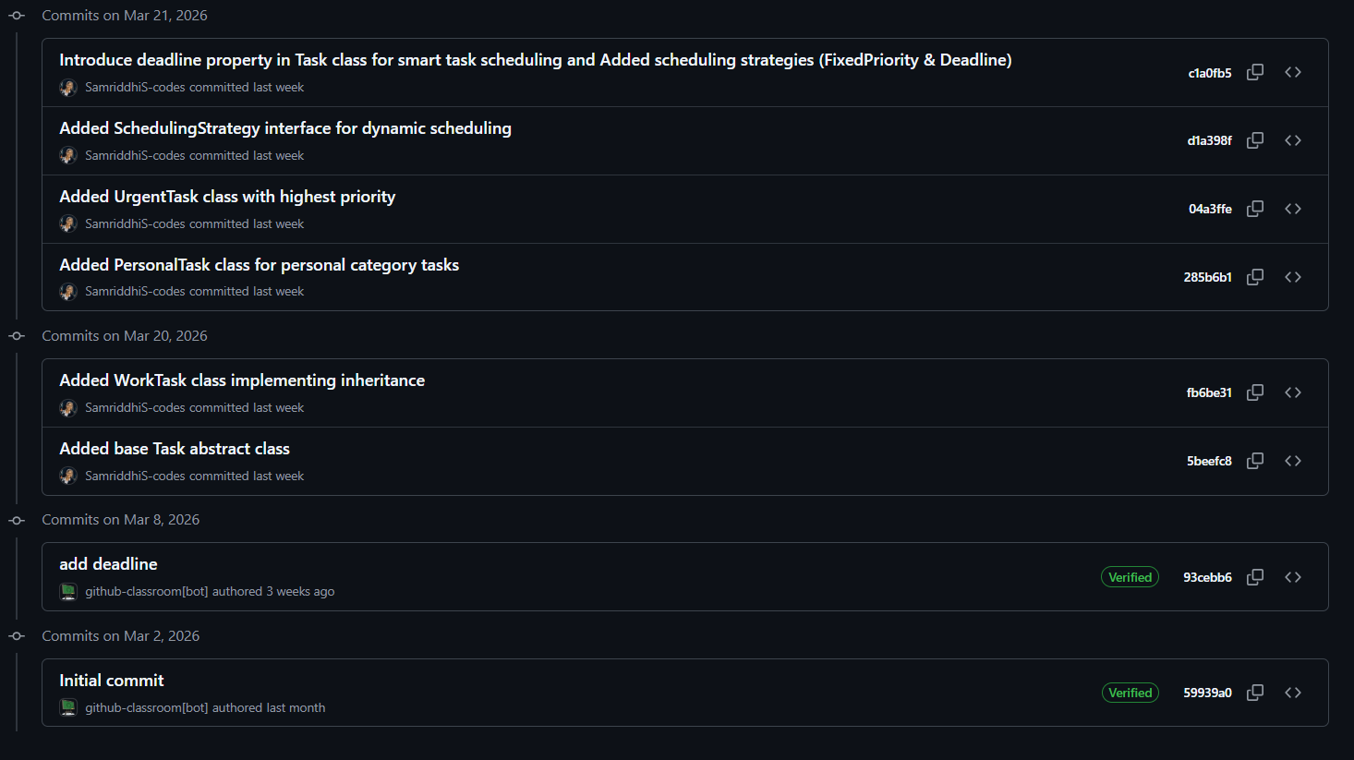
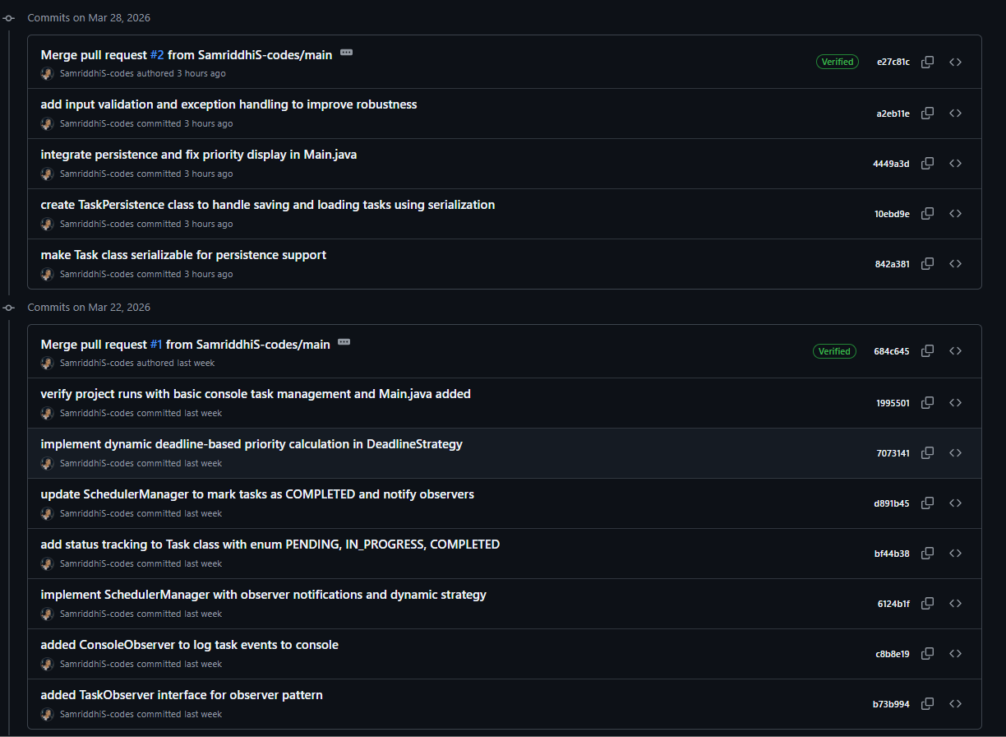

8. Conclusion & Future Scope
Conclusion
The Smart Task Scheduler successfully demonstrates the application of Object-Oriented Programming concepts and design patterns. It provides a flexible and efficient system for managing tasks dynamically.
The use of abstraction, encapsulation, inheritance, and polymorphism ensures clean and maintainable code. The integration of Strategy and Observer patterns enhances modularity and scalability.

Future Scope
- Development of a GUI using JavaFX or Swing
- Integration with databases (MySQL, SQLite)
- AI-based priority prediction
- Mobile or web-based version
- Notification system (email, push alerts)

